- Map issue
https://debtfree.thedevguys.co.nz/contact-us/
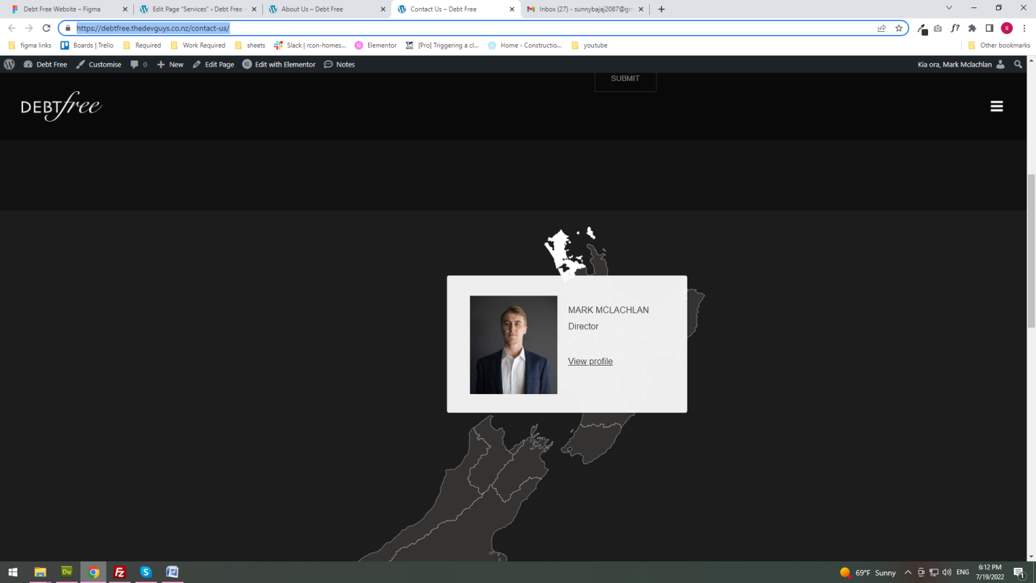
I am able to do what was asked in the design but they asked to open the team popup when this section is clicked for that we need pro version of the plugin
https://debtfree.thedevguys.co.nz/wp-admin/edit.php?post_type=igmap&page=interactive-geo-maps-pricing&trial=true
you can check here
- 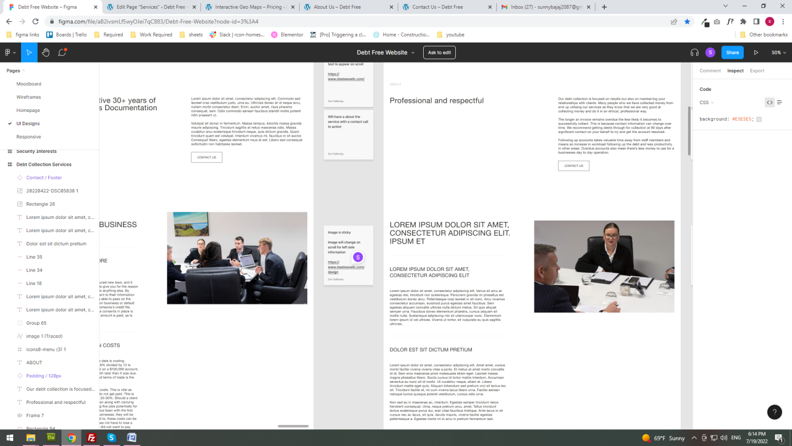 for this section they asked image to be sticky and change with the left section scroll. There is no widget available in elementor with this type and I tried doing with jquery but the width and heigt of content changed and I was not able to find out how to trigger because it has to be done with responsive also.

